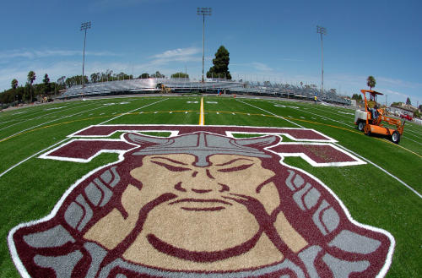
z

Events and Order:
1600m
4x800
4x200
1600 SMR - (2,2,4,8)
DMR
800 SMR – (1,1,2,4)
Pole Vault
Shot Put
Disc
L.J.
T.J.
H.J.

Medals: Top 3 overall per event / per division

Entries: California MileSplit
Deadline:
Wednesday, 2/14/24 - 11 PM.

School Entry Fee: $300
Checks: THS Track
Due: Tuesday, 2/13/24

Mail: Kyle Irvine
THS Track and Field
2200 W. Carson St.
Torrance 90501

DIRECTIONS TO ZAMPERINI
See Map Below

Contact:
Kyle Irvine
310-283-1878 - cell
Isa4522@startmail.com

Louis Zamperini Invitational
February 17, 2024
Zamperini Stadium:
2320 Crenshaw Bl.
Torrance, CA 90501

Start Time: 8:30am – Running / Field

School Entry Fee: $300

Entries:
1600m - Unlimited
Relays – 3 teams per relay / per division

Field Events:
S.P. / Disc. – 4 per school / per division
L.J. / T.J. – 4 per school / per division
H.J. / P.V. – 4 per school / per division

General Admission:
Adults - $10
Seniors - $5
H.S. Students - $5
Children under 12 - Free

www.thstf.com/zamperini
www.thstf.com/directions

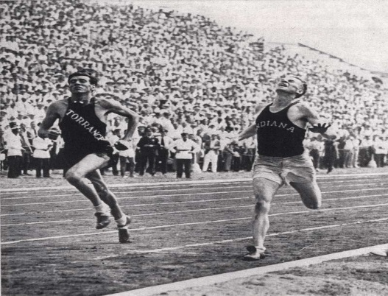

Louis Zamperini Invitational

Levels: Varsity & F/S - Boys & Girls

Events:
1600m – Heats per division
4x800 – 4 races (one race per level) no heats
4x200
1600 SMR (2, 2, 4, 8)
DMR – Two races (combined girls / combined boys)
800 SMR (1,1,2,4)

Field Events: PV, S.P., DISC, H.J., L.J., T.J.

Medals: top 3 overall per event / per division

Approximate:

Event #1 1600m– Boys / Girls 8:30am Event #27- Pole Vault – 8:30am

Event #2 4x800 – F/S -Boys 10:00am Opening Height – 6” 0” – F/S – G
7’ 0” – V/G
Event #3 4x800 – F/S - Girls 10:15am 8’ 0” – F/S - B
10’ 0” – V/B
Event #4 4x800 – Varsity – Girls 10:30am
Event #28 – High Jump – (Two Pits) 8:30am
Event #5 4x800 – Varsity – Boys 10:45am
Opening Heights – 3’ 8” / 4’8”
Event #6 4x200 – F/S - Boys 10:55am
Event #29 Long Jump Two Pits
Event #7 4x200 – F/S Girls 11:05am
Varsity Boys 8:30am #1
Event #8 4x200 – Varsity – Girls 11:15am Varsity Girls 8:30am #2
F/S – Boys 10:15am #1
Event #9 4x200 – Varsity – Boys 11:25am F/S – Girls 10:15am #2

Event #10 1600 SMR– F/S Boys 11:35am Event #30 Triple Jump

Event #11 1600 SMR– F/S Girls 11:50am Varsity Boys 12:00pm #1
Varsity Girls 12:00pm #2
Event #12 1600 SMR – Var Girls 12:10pm F/S – Boys 1:30pm #1
F/S – Girls 1:30pm #2
Event #13 1600 SMR – Var Boys 12:20pm

Event #14 DMR – Girls - Combined 12:40pm Event #31- Shot Put 8:30am

Event #15 DMR – Boys - Combined 1:10pm V/B
F/S - B
Event #16 800 SMR– F/S Boys 1:30pm F/S - G
V/G
Event #17 800 SMR – F/S Girls 1:45pm
Event #32 – Discus 8:30am
Event #18 800 SMR- Var Girls. 2:00pm
V/G
Event #19 800 SMR Var - Boys 2:15pm F/S - G
F/S – B
V/B

