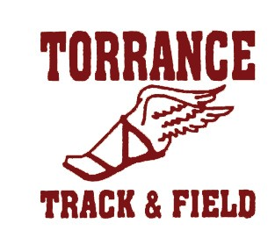
Torrance High School
2200 W Carson Street • Torrance, CA 90501
Kyle Irvine • Head Coach Ph: (310) 283-1878
www.thstf.com

Email: isa4522@startmail.com

TORRANCE HIGH TRACK & FIELD PROGRAM: TEAM RULES

- Student/Athletes must maintain a cumulative G.P.A. of 2.0 or above and no more than one Unsatisfactory in Citizenship to participate in the track program.

- The use of ANY drugs, alcohol and smoking is strictly prohibited.

- During TRACK SEASON: daily practice and track meets have priority over outside Activities. This includes club sports, school clubs, or any other activity. You are not allowed to leave practice early and or meets early to attend any of these activities.
- THS TRACK & FIELD is a competitive high school sport and not a part time sport or a recreation. You must be 100% committed to the program.

- Student/Athletes must be on time to all meetings, practices, and meets.
- Players may not practice, workout, or tryout with an outside Track Team until our season has been completed.
- All Tartar Track Members must act in accordance with proper manners always, and do nothing that will bring embarrassment to THS, the Athletic Program, or the TRACK program.
- To compete an athlete must practice / train daily with the track team.
- Leaving or missing practice / meet early to attend a club activity, club sports, or any other activity ahead of THS TRACK, you have made Track a part time sport and recreation.
- Uniforms must be worn in proper fashion. Only THS TRACK gear is acceptable.

. . . . . I understand these rules and realize that the breaking of any one of these rules could result in the immediate dismissal from the track program.

___________________________________________ DATE: ____________________
Athlete’s Signature

______________________________________________ DATE: _____________________
Parent’s Signature

